1. Stored Procedure naming

**[ModuleSchema].[ModuleSchema_SP_Stored_Procedure_Action_Name]**

**ModuleSchema** – Module Schema name like CST, GEN etc.

**SP –** It is a key to identity the SQL object as Stored Procedure

**Stored_Procedure_Action_Name –** Use capital letter in word starting and all other letters should be small case (Camel Casing)

**Example:-**

[CST].[CST_SP_Direct_Cost_Labour_Estimation_Details_Insert]

[CST].[CST_SP_Direct_Cost_Labour_Estimation_Details_Update]

[CST].[CST_SP_Direct_Cost_Supporting_Estimation_Details_Delete]

[CST].[CST_SP_Direct_Cost_Material_Estimation_Details_List_Get]

[CST].[CST_SP_Worksheet_List_Get]

Direct_Cost_Labour_Estimation_Details – Module_Submodule_Name

1. Closing brackets for input variables

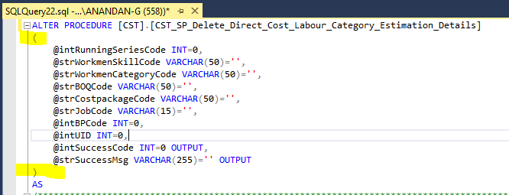

1. Mention Stored Procedure Comments In-between the Input variable declaration & SP beginning

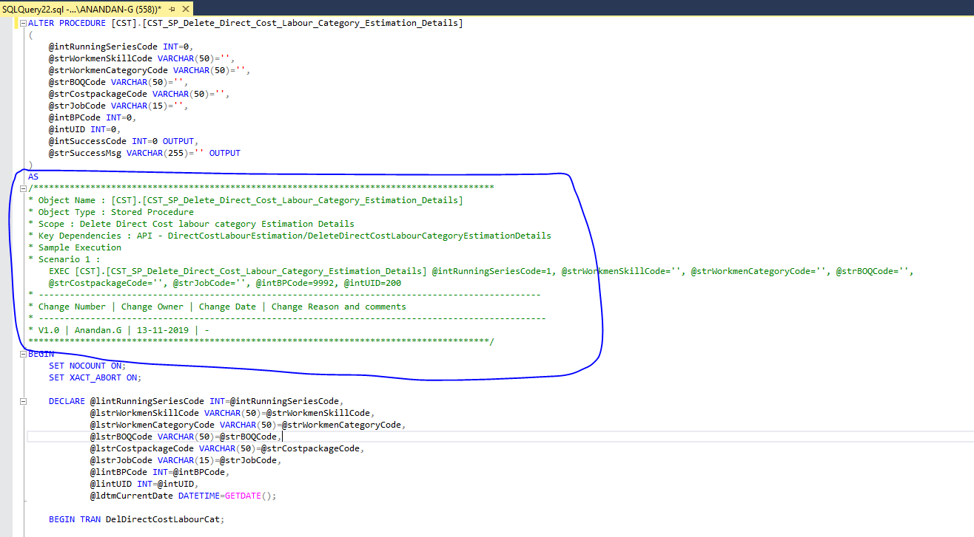

1. Don’t use input variables directly into queries. Instead of this use local variables

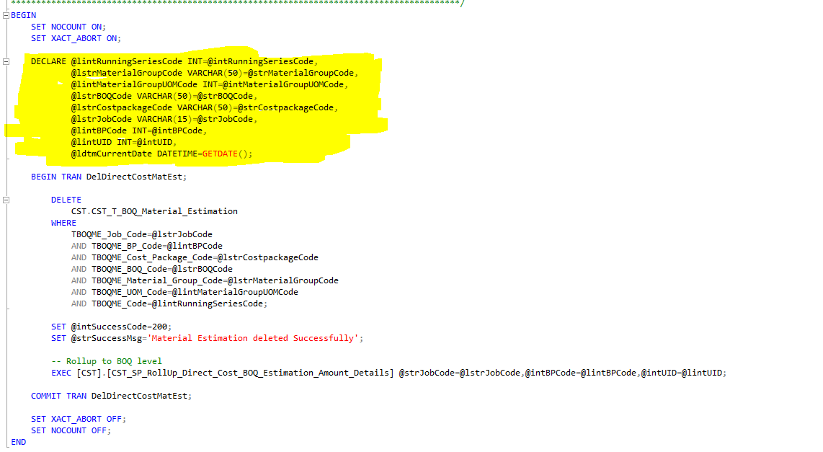

1. Use begin tran and commit tran for insert, update / delete SP’s

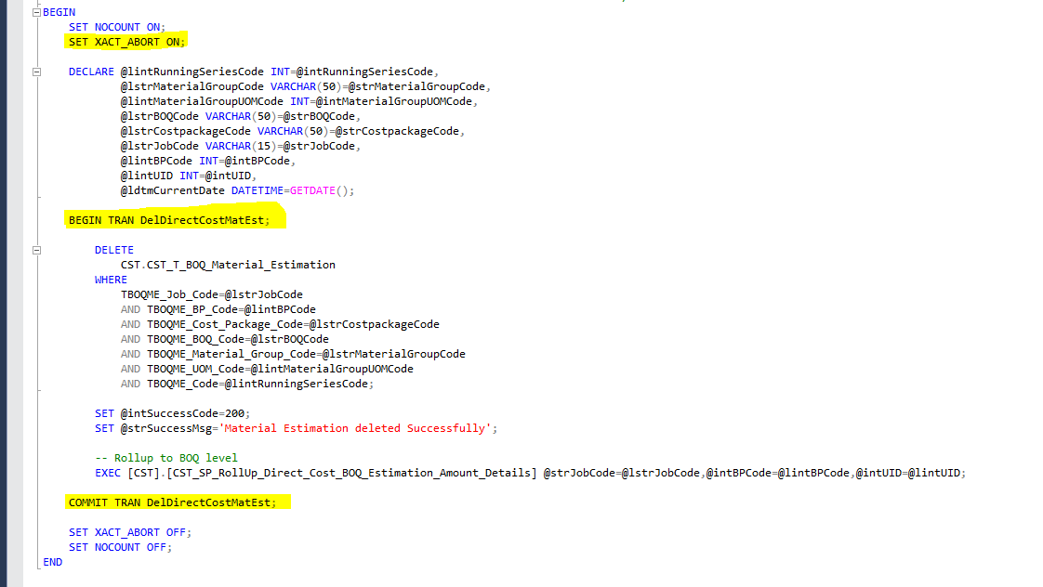

1. Put data type short code in variable prefix (short code 🡪 refer SQL architecture document). If it is local variable put start letter as **l.**

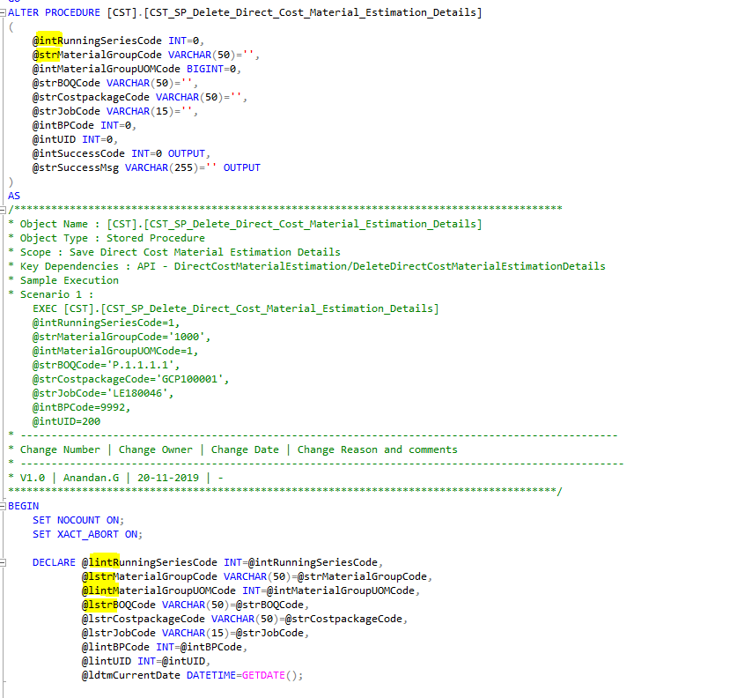

1. Use As keyword for output alias

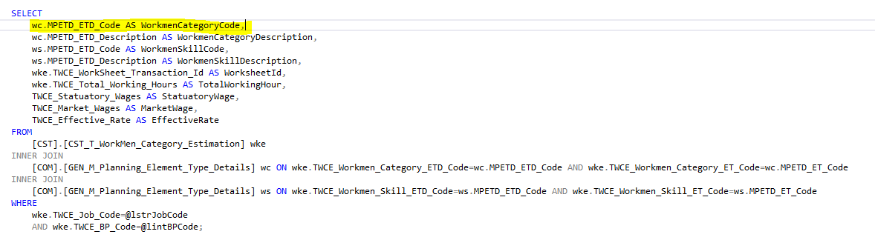

1. Query alignment

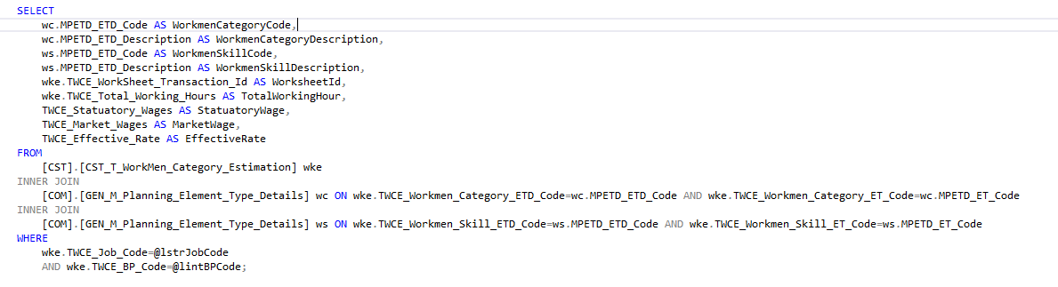

1. Put semi-colon in every line end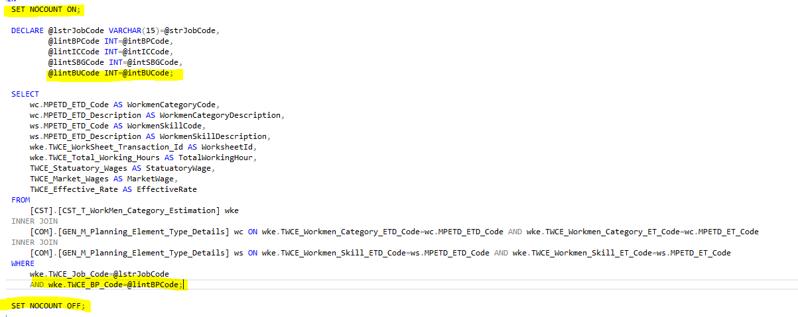
2. Use order by statements in API not in SQL
3. Don’t use distinct key word. If needed use group by

-- old table – we will delete this table after development completed

--DROP TABLE IF EXISTS [BQS].[BQS_L_Discipline_BOQ_Category];

CREATE TABLE [BQS].[BQS_L_Cluster_Element_Discipline_BOQ_Group](

       [LDBQG_CE_Code] [int] NOT NULL,

       [LDBQG_CED_Code] [int] NOT NULL,

       [LDBQG_Discipline_Code] [varchar](15) NOT NULL,

       [LDBQG_BOQ_Category_Code] [varchar](15) NOT NULL,

       [LDBQG_BOQ_Group_Code] [varchar](15) NOT NULL,

       [LDBQG_Is_Additional_Description_Applicable] [char](1) NOT NULL,

       [TPBOG_Sort_Order] [int] NOT NULL,

       [LDBQG_Inserted_On] [datetime] NOT NULL,

       [LDBQG_Inserted_By] [int] NOT NULL,

       [LDBQG_Updated_On] [datetime] NOT NULL,

       [LDBQG_Updated_By] [int] NOT NULL

CONSTRAINT [PK_BQS_L_Discipline_BOQ_Group] PRIMARY KEY CLUSTERED

(

       [LDBQG_CE_Code] ASC,

       [LDBQG_CED_Code] ASC,

    [LDBQG_Discipline_Code] ASC,

    [LDBQG_BOQ_Category_Code] ASC,

    [LDBQG_BOQ_Group_Code] ASC

)WITH (PAD_INDEX = OFF, STATISTICS_NORECOMPUTE = OFF, IGNORE_DUP_KEY = OFF, ALLOW_ROW_LOCKS = ON, ALLOW_PAGE_LOCKS = ON) ON [FGBQS01]

) ON [FGBQS01]

GO

ALTER TABLE [BQS].[BQS_L_Discipline_BOQ_Group] ADD  CONSTRAINT [DF_LDBQG_Inserted_On]  DEFAULT (getdate()) FOR [LDBQG_Inserted_On]

GO

ALTER TABLE [BQS].[BQS_L_Discipline_BOQ_Group] WITH CHECK ADD  CONSTRAINT [FK_LDBQG_Discipline_Code] FOREIGN KEY([LDBQG_Discipline_Code])

REFERENCES [BQS].[BQS_M_Design_Disciplines] ([MDDS_Discipline_Code])

GO

ALTER TABLE [BQS].[BQS_L_Discipline_BOQ_Group] CHECK CONSTRAINT [FK_LDBQG_Discipline_Code]

GO